Study of Power Transmission Methods, Gears, and Fasteners
Vyas Bodke
Research Subsystem
Robo Manipal, MIT
Manipal, India
vyas.mitmpl2026@learner.manipal.edu
Abstract— This report covers gear, belt, chain and rope drives, their working, advantages, disadvantages and applications. It also explains the types of gears and gear trains, basic gear terminology, speed ratios and types of fasteners.

I. Introduction
Power transmission is the transfer of mechanical power from a motor or another source to where it is needed. For ex, a motor may rotate too fast to drive a robot wheel directly. A transmission reduces speed and increases the torque. It can also transfer motion between shafts or change its direction.
The part supplying motion is called the driver, and the part receiving it is called the driven member. A shaft carries rotating parts such as gears and pulleys. Torque is the turning effect of a force and is measured in N m. Speed is measured in revolutions per minute (rpm.
In an ideal transmission, input and output power are equal. Real output power is lower because of friction and other losses.

II. Gear Drives

A. Construction and Working
A gear drive consists of toothed wheels mounted on shafts. Bearings support the shafts and keep the gears at the required distance. When the driving gear rotates, its teeth push the teeth of the driven gear and make it rotate. Lubrication reduces friction and wear between the teeth.
Gears are called positive drives because their teeth engage to transfer motion without slipping. Two external gears rotate in opposite directions. An external gear meshing with an internal gear rotates in the same direction as it, when both centres are fixed. The smaller gear in a pair is called the pinion.

B. Advantages and Limitations
Gear drives give high torque in a small space and maintain an accurate speed ratio. Different types are available for parallel, intersecting and non intersecting shafts.
Gears need accurate manufacture, alignment and lubrication, which increases their cost. They are mainly used between shafts that are close together. Some types are noisy at high speeds, and sudden overloads can damage them.

III. Types of Gears

A. Spur Gears
Spur gears have straight teeth parallel to the shaft axis. They are used between parallel shafts and are simple to manufacture. Their teeth engage less gradually than helical teeth, so they can be noisy at high speed. They produce tangential and radial forces, but ideally no force along the shaft.
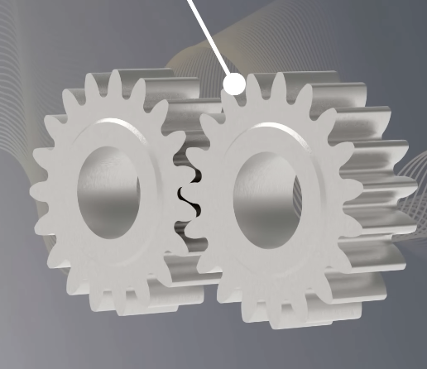
Spur gears are used in clocks, small gearboxes and gear pumps. They are useful in a simple robot gearbox where low cost and easy manufacture are important.

B. Helical Gears
Helical gears have teeth cut at an angle to the shaft axis. In a normal parallel shaft pair, the teeth slope in opposite directions at equal angles. Contact starts at one end of the tooth and is along the width. This makes it smoother and quieter than spur gears.
The inclined teeth produce thrust which acts along the shaft and must be supported by bearings. They are used in vehicle transmissions and industrial gearboxes.
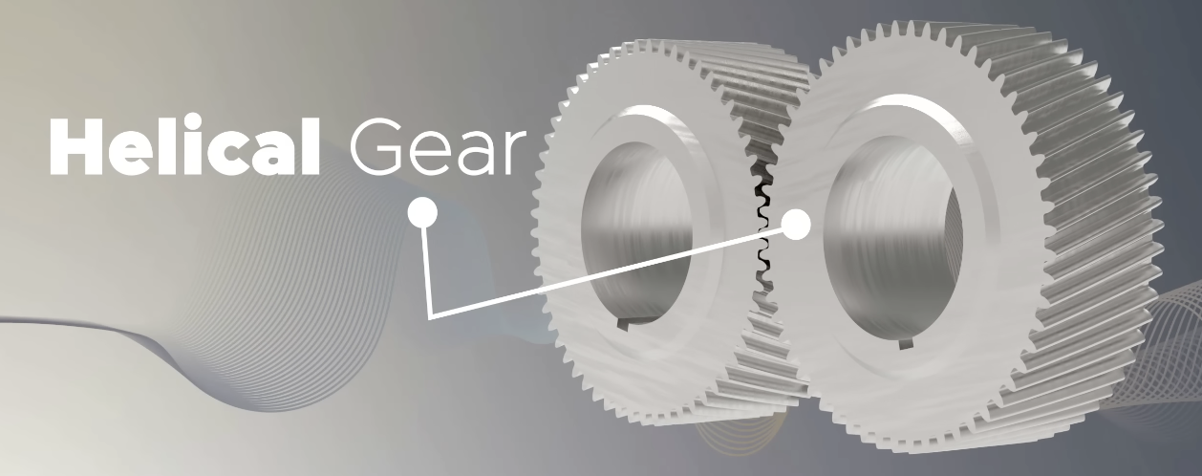

C. Double Helical and Herringbone Gears
Double helical gears have two sets of teeth inclined in opposite directions. The axial forces from the two halves oppose each other and cancel when the load is shared equally. A double helical gear usually has a gap between the halves. In a herringbone gear, the teeth meet in a continuous V shape.
They are used in heavy industrial drives where high load capacity and smooth running are needed. They are more difficult and expensive to manufacture than spur gears.
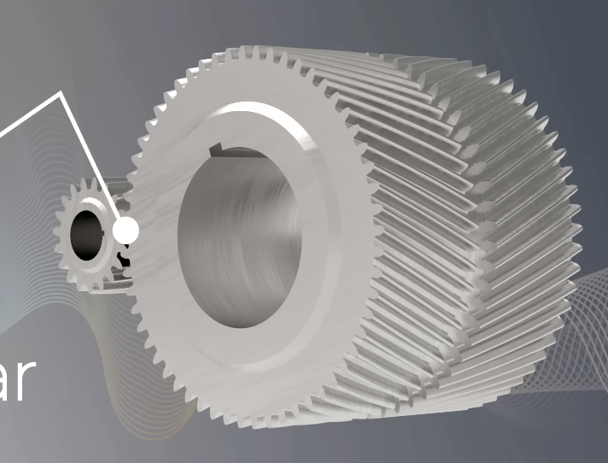

D. Bevel Gears
Bevel gears have teeth on a cone-shaped surface and connect shafts whose axes intersect, usually at 90 degrees. Straight bevel gears have straight teeth. Spiral bevel gears have curved teeth for smoother engagement. Mitre gears have equal numbers of teeth and give a 1 is to 1 ratio, usually with a 90 degree change in shaft direction.
Bevel gears are used in right-angle drives and vehicle differentials. They need accurate mounting and bearings that can support the forces from the gear teeth.
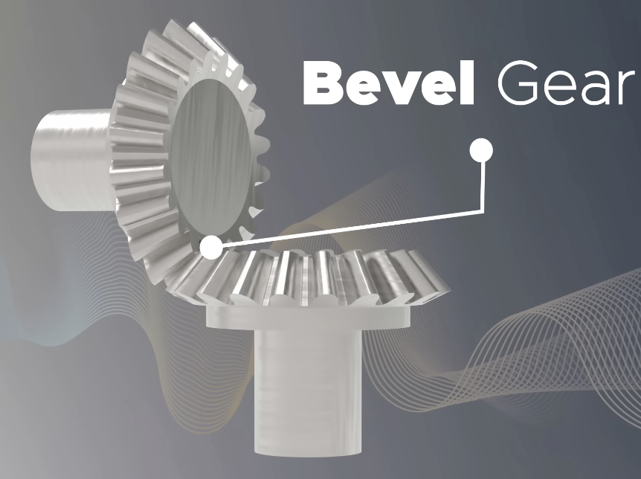

E. Worm and Worm Wheel
A worm is a screw-shaped part that meshes with a worm wheel. Their shafts are usually at 90 degrees and do not intersect. A single-start worm moves the wheel by one tooth in each revolution. A two-start worm moves it by two teeth.
Worm drives give a large speed reduction in one stage. They are used in compact reducers, machine tools and some conveyor drives. Sliding between them produces heat and reduces efficiency.
Some worm drives are self locking, meaning the wheel cannot easily turn the worm backwards. It is sometimes useful in elevators. This depends on the lead angle and friction, so it is not a property of every worm drive. A separate brake is needed where the load must be held safely.
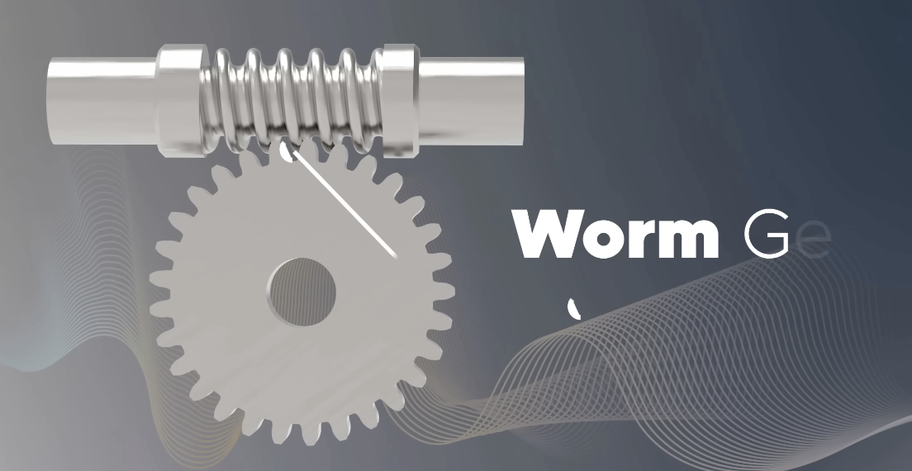

F. Hypoid Gears
Hypoid gears are similar to spiral bevel gears, but their shaft axes are offset and do not intersect. This allows the drive shaft to be placed lower. They are used in the final drives of many rear wheel drive vehicles.
They run smoothly and carry high loads, but the sliding contact needs to be lubrication. The main difference from bevel gears is the offset between the shaft axes.
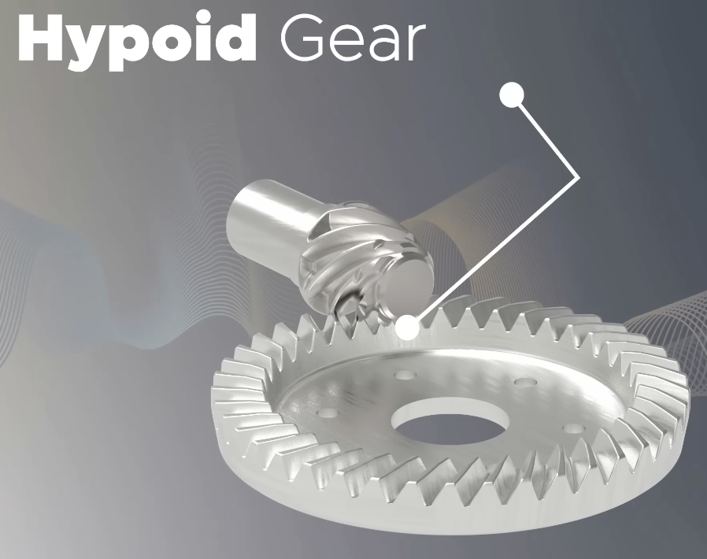

G. Rack and Pinion
A rack is a straight bar with teeth that meshes with a pinion. Rotating the pinion moves the rack in a straight line. The can also work in reverse, with the rack turning the pinion.
These are used in vehicle steering, sliding gates and machine positioning. In one pinion revolution, the rack moves a distance equal to the pinion's pitch circle circumference.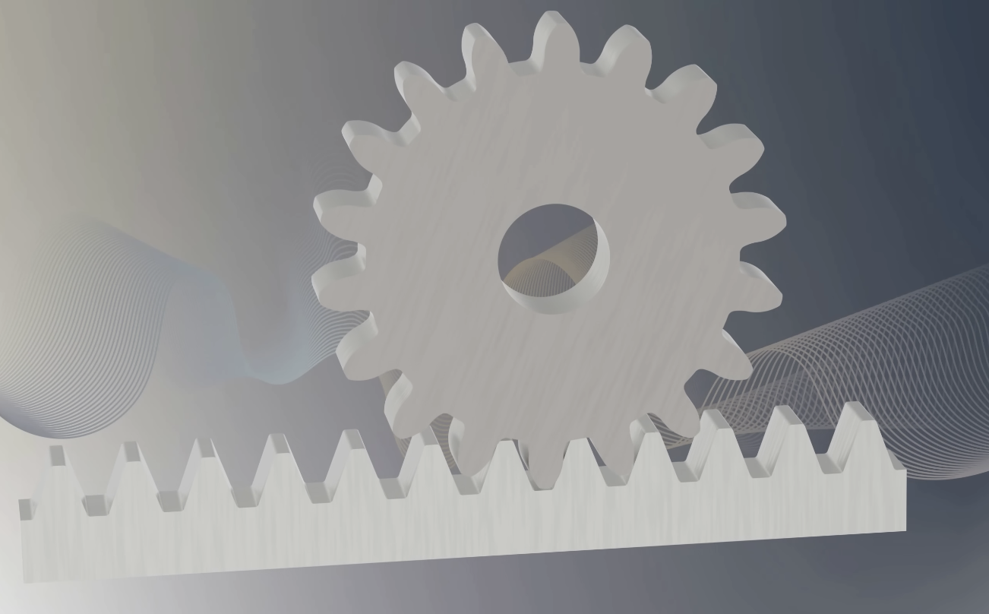

H. Internal Gears
An internal gear has teeth on the inside of a ring. A smaller external gear meshes with it. Internal gears allow a compact arrangement and are commonly used as the ring gear in planetary gear trains.
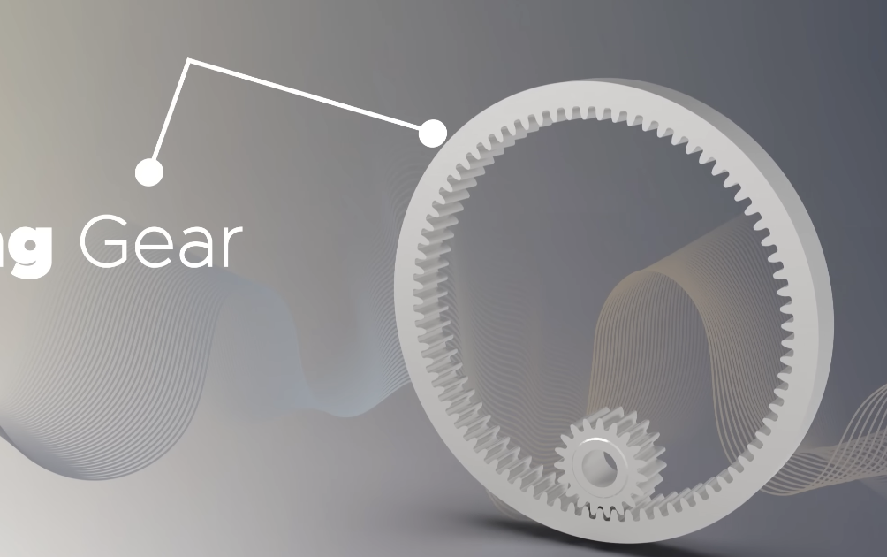

IV. Gear Terminology

A. Main Circles and Tooth Dimensions
Pitch circle: The imaginary circle representing a smooth wheel that would give the same rolling motion as the gear. For standard spur gears at the standard centre distance, the two pitch circles touch and roll without slipping. Its diameter is called the pitch diameter, d.
Addendum circle: The circle passing through the tooth tips. Dedendum or root circle: The circle passing through the bottoms of the tooth spaces.
Addendum: The radial distance from the pitch circle to the tooth tip. Dedendum: The radial distance from the pitch circle to the root. Their sum gives the total tooth depth. Dedendum is usually greater so there is clearance below the mating tooth tip.
Face: The tooth side above the pitch circle. Flank: The tooth side below it. Top land: The surface at the tooth tip. Root fillet: The rounded part where the tooth joins its base. This rounding reduces stress concentration.
Face width is the width of the gear teeth measured along the shaft. Tooth thickness is measured around the pitch circle. A wider gear can carry more load if the teeth remain properly aligned and share the load across their width.
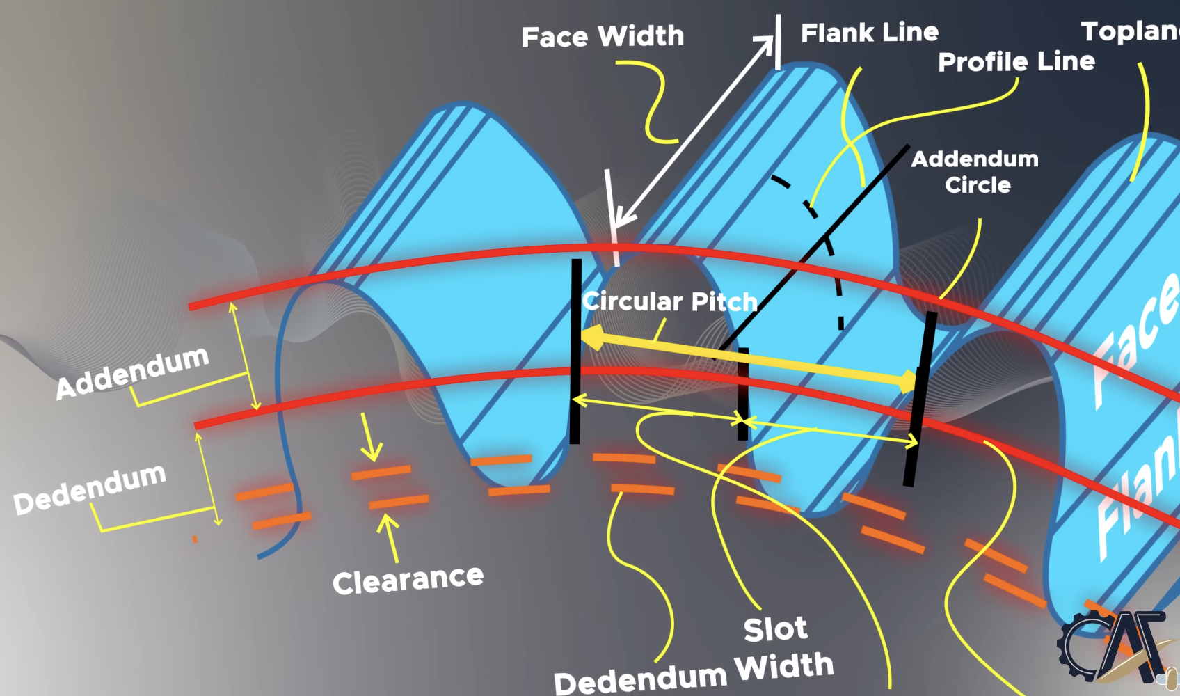

B. Pitch and Module
Circular pitch p is the distance along the pitch circle from a point on one tooth to the same point on the next tooth. It equals the tooth thickness plus the width of the neighbouring tooth space. It is measured as a length.
Module m describes the tooth size. It is the pitch diameter in millimetres divided by the number of teeth z. Choosing the module and tooth count fixes the pitch diameter. A larger module means larger teeth. Ordinary spur gears need the same module and pressure angle to mesh correctly.
$m = d / z p = πm d = mz$
Angular pitch is the angle between neighbouring teeth and equals 360 degrees divided by z.
For a gear with 30 teeth and a 60 mm pitch diameter, the module is 2 mm and circular pitch is about 6.28 mm. A 20 tooth gear of the same module has a pitch diameter of 40 mm. The standard centre distance for this pair is (60 + 40)/2 = 50 mm.

C. Backlash and Clearance
Backlash is the small gap between the sides of mating teeth. When the driver reverses, it moves through this gap before it starts pushing the other gear in the opposite direction. This causes a small amount of lost movement and affects positioning accuracy.
Some backlash is needed for lubrication and thermal expansion. Clearance is the radial gap between the tip of one gear s tooth and the bottom of the other gear's tooth space. It prevents the tip from hitting the root.

D. Pressure Angle and Tooth Profile
Pressure angle is the angle between the direction of the tooth contact force and the common tangent to the pitch circles, mostly it is 20 degrees. The contact force turns the gears but also pushes them apart, so the shafts and bearings must support it.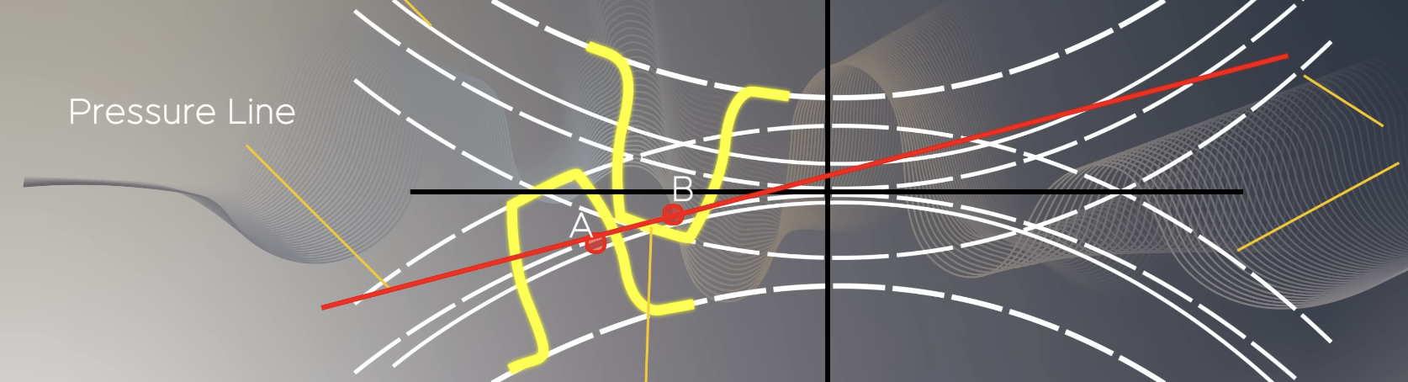
Contact ratio describes the overlap between successive pairs of teeth in contact. One tooth should start taking over before the other tooth leaves contact.

V. Gear Ratio and Torque

A. Reduction Ratio and Torque
Let z1 and n1 be the tooth count and speed of the driver, and z2 and n2 those of the driven gear. The reduction ratio i is the input speed divided by the output speed.
$i = z2 / z1 = N1 / N2$
A 20 tooth gear at 900 rpm drives a 60tooth gear at 300 rpm. This gives a 3 is to 1 reduction. If the input torque is 2 N m, the ideal output torque is 6 N m. At 90 percent efficiency, the output torque is 5.4 NM.
$T2 = η × i × T1$
Here, T1 is input torque, T2 is output torque and eta is efficiency.
A small gear driving a larger gear reduces speed and increases available torque. A large gear driving a smaller gear increases speed and reduces torque. Equal tooth counts give a 1 is to 1 speed ratio. Actual output torque also depends on the losses in the drive.

B. Velocity Ratio
Speed divided by input speed is the velocity ratio for gears and belts. A 20 tooth driver and 60 tooth driven gear therefore have a velocity ratio of 1 by 3, or a reduction ratio of 3 to 1.

VI. Gear Trains

A. Simple Gear Train
A simple gear train has one gear on each shaft. The gears in between are idlers. Each external gear mesh reverses the direction of rotation. When one idler, the input and output rotate in the same direction.
The overall ratio depends on the tooth counts of the first and last gears. The idler helps change the direction or connect separated shafts, but its tooth count does not change the total ratio.

B. Compound Gear Train
In a compound train, at least one shaft carries two gears fixed together. These gears rotate at the same rpm. One receives motion from the previous gear, and the other drives the next gear. Several stages give a large reduction without needing one very large gear.
This arrangement is used in motor gearboxes.

C. Reverted Gear Train
A reverted train is a compound train with the input and output axes on the same line. The input and output shafts still rotate independently. It is useful in some clock mechanisms and reducers where both shafts need to line up.
In a standard two stage reverted spur train, both gear pairs must have the same centre distance. Their pitch diameter sums must therefore be equal. If all gears have the same module, zA + zB =zC + zD.

D. Planetary or Epicyclic Gear Train
A planetary train has a central sun gear, planet gears around it and an outer ring gear with internal teeth. A carrier holds the planet shafts. The planets spin on their own axes and can also move around the sun, carrying the carrier with them.
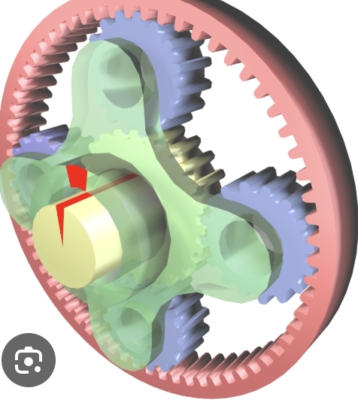
A common arrangement holds the ring fixed, drives the sun and takes output from the carrier. The reduction ratio is then 1 + ring teeth by sun teeth. Holding a different member fixed changes it, so this formula applies only to that arrangement.
Planetary gears provide a compact reduction with the input and output on the same axis. Several planets share the load, allowing more torque to be transmitted in a small space. They are used in cordless screwdrivers, robot actuators and automatic transmissions. Their main disadvantage is more complicated manufacture and assembly.

VII. Belt Drives

A. Construction and Working
A belt drive has two pulleys connected by a belt. Flat belts and V belts transfer power through friction with the pulleys. Initial tension keeps the belt in contact with them. During operation, one side has higher tension and is called the tight side. The other is the slack side. The difference in tension produces the driving torque.
Ignoring slip, N1D1 = N2D2, where N is rpm and D is pulley pitch diameter. A 100 mm driver pulley at 1000 rpm driving a 200 mm pulley gives an output of 500 rpm.

B. Types and Arrangements
Flat belts have a rectangular cross section and run over flat pulleys. They give smooth operation and are useful over relatively long distances between shafts. Enough tension and contact with the pulley are needed to prevent slip.
V belts have a trapezoid cross section and fit into V shaped pulley grooves. The wedging action increases grip. They are used in fans, compressors and other machines.
Timing belts have teeth that lock with grooves in the pulley. Their ratio depends on the pulley tooth counts, and they do not normally slip. They are used in engine timing systems and 3D printers. The belt and pulley profiles must match, and incorrect tension or overload can cause teeth to jump or fail.
An open belt makes parallel shafts rotate in the same direction. A crossed flat belt makes them rotate in opposite directions, but the belt can wear where it crosses.

C. Characteristics and Applications
Slip occurs when the belt slides over the pulley because there is not enough grip.
Belts are quiet, absorb shock and do not need lubrication at the pulleys. They can connect shafts farther apart than a gear pair. They wear with use mostly. Excess tension loads the bearings, while insufficient tension causes slip or tooth jumping.
A V belt is suitable for a fan where a small speed variation is acceptable. A timing belt is useful for a printer axis where movement must be accurate. Timing belts need matching toothed pulleys and are often more expensive. Friction belts also slip during overload.

VIII. Chain Drives

A. Construction and Working
A chain drive uses a chain running over toothed wheels called sprockets. The joints let it bend around the sprockets, whose teeth engage the chain to transfer motion without ordinary frictional slip.
The average reduction ratio equals the driven sprocket tooth count divided by the driver tooth count. A 15 tooth driver and 45 tooth driven sprocket give a 3 to 1 reduction. Both sprockets rotate in the same direction in the usual open chain arrangement.

B. Types and Maintenance
Roller chains are used in bicycles, motorcycles and industrial machines. Multiple row chains can carry greater loads. Silent chains have special toothed links for smooth running.
Chains need lubrication and protection from dirt. A worn chain may ride up or jump the sprocket teeth. The chain needs correct alignment and suitable slack, and both the chain and sprockets should be checked for this.

C. Advantages and Limitations
Chains can carry high loads over moderate distances between shafts. They are generally noisier than belts and need more maintenance.

IX. Rope Drives

A. Construction and Working
A rope drive uses rope running over grooved pulleys called sheaves. Friction between the rope and groove transfers power. Several ropes can be used side by side to share load. Like a friction belt, the rope has tight and slack sides and can slip if grip is not enough.

B. Fibre and Wire Ropes
Fibre ropes are made from natural or synthetic fibres. They were used in traditional drives to transmit power over long distances. They are flexible and absorb shock, but stretching, moisture and wear affect their performance.
Wire ropes are made of steel wires grouped around a core. They carry high pulling loads in cranes and other machines. A traction elevator uses friction between the ropes and a driven sheave. A drum hoist lifts the load by winding rope onto a drum.

C. Advantages and Limitations
Ropes can carry a pulling force over long distances and pass around sheaves to change its direction. Small sheaves bend the rope sharply and can shorten the life. Wire ropes need inspection for broken wires and corrosion. Fibre ropes need checking for cuts and abrasion.
Rope stretch and possible slip make rope drives unsuitable for precise timing.

X. Fasteners
Fasteners join parts together or hold them in position. They are selected according to the load, material, available space and whether the parts need to be removed for maintenance.

A. Temporary and Permanent Fasteners
Temporary fasteners allow a joint to be taken apart without damaging the main parts. Bolts, nuts and screws are common examples. They are useful in motor mounts, machine covers and assemblies that need repair or adjustment.
Permanent fasteners are used where regular removal is not required. Rivets are a common example. They normally need to be drilled or cut out to separate the parts. Welding and adhesive bonding also make permanent joints, but they are joining methods rather than separate fasteners.

B. Bolts and Screws
A bolt usually passes through holes in the parts and is tightened using a nut. A screw usually fits into a threaded hole or forms a thread in the material.
Hex bolts have six sided heads and are used in frames, brackets and motor mounts. Socket head screws are tightened with an Allen key and are useful where there is little space around the head for a spanner.
Countersunk screws fit into a recess so their heads remain flush with the surface. They are used in covers and plates where a projecting head could obstruct movement. Self tapping screws form or cut threads in a suitable hole and are used in sheet metal and plastics. Set screws press against a shaft to hold a knob, collar or small hub in place.

C. Nuts
Nuts have internal threads and fit with matching bolts. Hex nuts are used in general machine assembly. Wing nuts can be tightened by hand and are useful for parts that need frequent adjustment.
Nylon insert locknuts resist loosening and are useful in assemblies exposed to vibration. Castellated nuts have slots for a split pin, which prevents the nut from turning freely. They are used in some steering assemblies.

D. Washers
Washers are placed under a bolt head or nut to spread pressure and protect the surface. Plain washers are useful on thin sheets and soft materials. Larger washers spread the load over a wider area.
Locking washers are intended to resist loosening. However, ordinary split spring washers should not be relied on under severe vibration. A suitable locknut or threadlocking compound should be used here.

E. Studs, Pins and Circlips
A stud is a threaded rod without a normal bolt head. One end can remain fixed in a component while a nut is removed from the other end. Studs are used in engine cylinder heads and housings that need repeated assembly.
Dowel pins keep parts accurately aligned. Clevis pins allow movement at a pivot, while split pins prevent a pin or slotted nut from coming loose. Circlips fit into grooves on shafts or inside holes and stop components like bearings from moving.

F. Rivets
A rivet passes through holes in the parts, and its end is deformed to hold them together. Solid rivets normally require access to both sides and are used in permanent sheet metal structures.
Blind rivets can be installed from one side. They are useful in enclosures and hollow sections where the back cannot be reached. Rivets are unsuitable for covers that need frequent removal because the rivet must usually be destroyed to open the joint.

G. Selection Acc to Application
A removable motor mount can use bolts and nuts. A cover requiring a smooth surface can use countersunk screws. A permanent sheet panel can use rivets, while a vibrating assembly needs correct tightening and a suitable locking method. For plastic parts opened repeatedly, a threaded metal insert and machine screw help reduce wear on the plastic.

References

IEEE conference templates contain guidance text for composing and formatting conference papers. Please ensure that all template text is removed from your conference paper prior to submission to the conference. Failure to remove template text from your paper may result in your paper not being published.

